Ideation Phase
Empathize & Discover
Date | 14 October 2026
Team ID
Project Name | Automated Network Request Management System
Maximum Marks | 4 Marks

Empathy Map Canvas:
An empathy map is a simple, easy-to-digest visual that captures knowledge about a user’s behaviours and attitudes. It is a useful tool to helps teams better understand their users.
Creating an effective solution requires understanding the true problem and the person who is experiencing it. The exercise of creating the map helps participants consider things from the user’s perspective along with his or her goals and challenges.
Reference: https://www.mural.co/templates/empathy-map-canvas
Example Persona: Enterprise Network Requester (Abraham Lincoln):
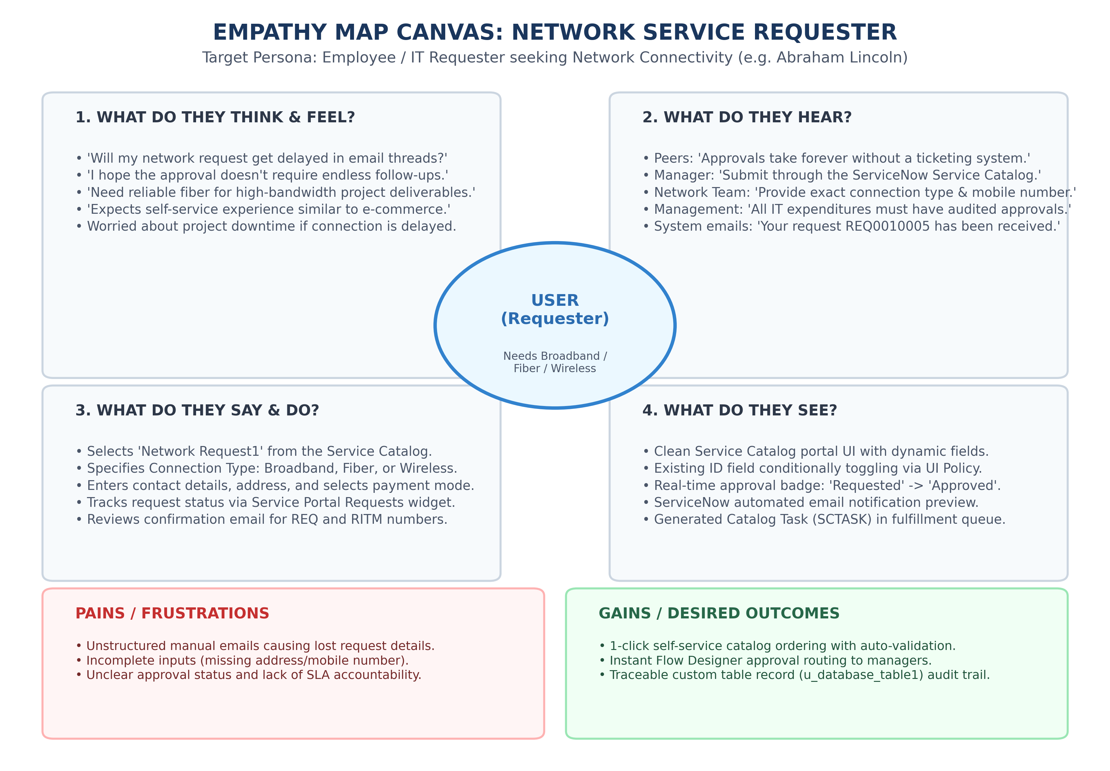
Figure 1.4: Empathy Map Canvas - Network Service Requester
Key Observations:
• Thinks & Feels: Anxious about project deadlines; relieved when a clean self-service form provides clear options.
• Hears: Peers and managers urging that requests must be formally submitted in ServiceNow for budget tracking.
• Says & Does: Opens Service Portal (/sp), selects 'Network Request1', inputs contact details and address, and places order.
• Sees: Real-time status badge 'Requested' -> 'Approved', instant email notification, and fulfillment progress.
• Pains: Lost emails, untracked approval delays, manual back-and-forth.
• Gains: Seamless self-service catalog, automated Flow Designer approval, and fast delivery.

